I have deleted and redeployed the script on the purchase order and made it enable for all the roles, employees and partners.

Please see the below script deployment screenshot.

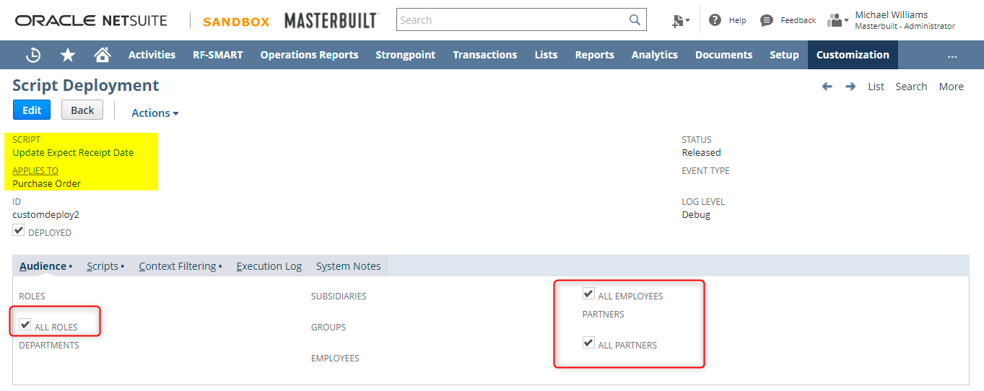

**Case 1:**

When inbound shipment is not populated on the custom record, Expected Receipt Date is changed on the PO line. The new changed date should be populated on the custom record. Please see the below screenshots.

Open PO#36162

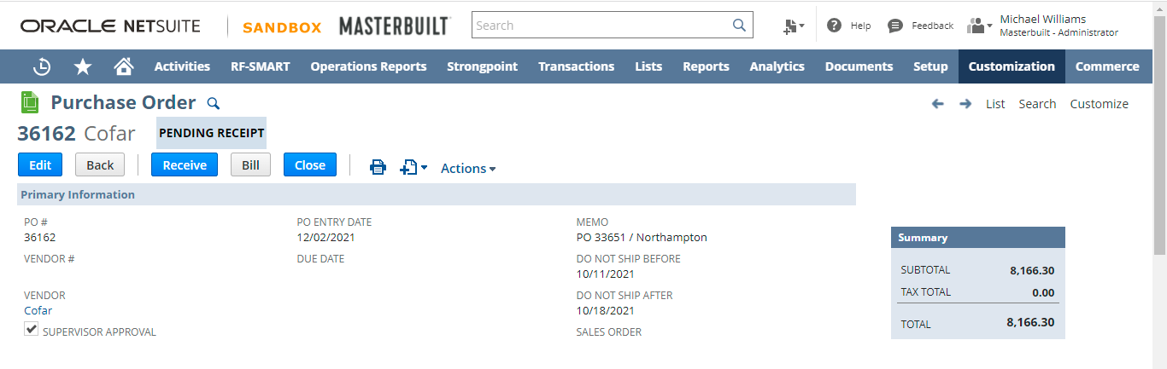

Click on the Edit button.

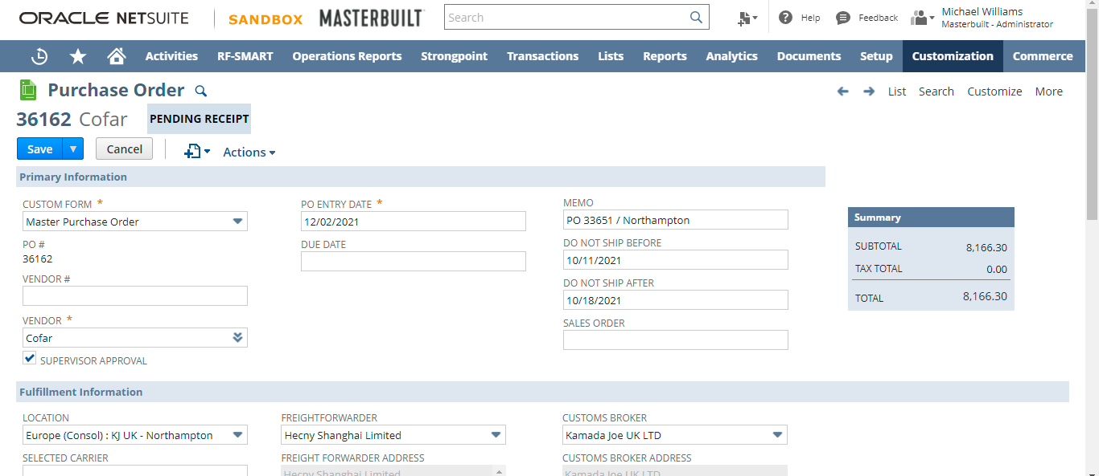

Go the Items sub tab and change the **expected receipt date** field.

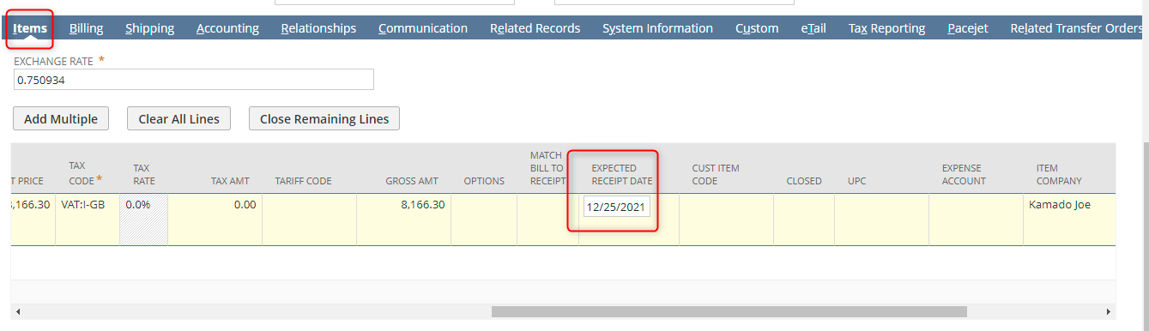

Change the expected receipt date from 12/25/2021 to 01/01/2022.

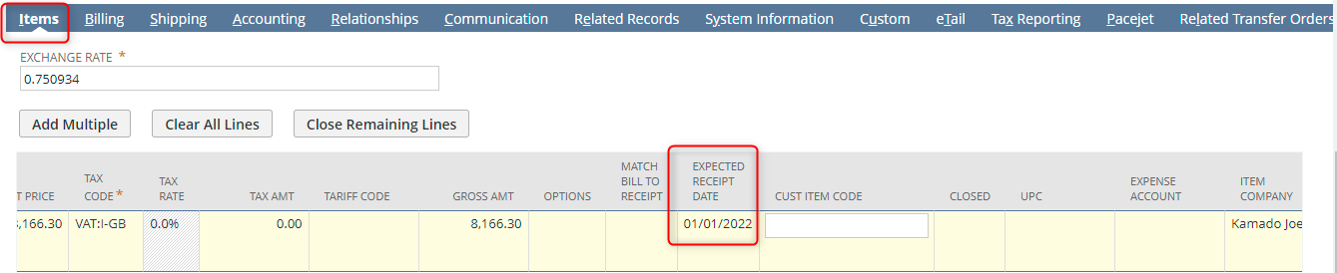

**PO Inbound Shipment Report Before Screen:**



**PO Inbound Shipment Report After Screen:**

Refresh the page once.

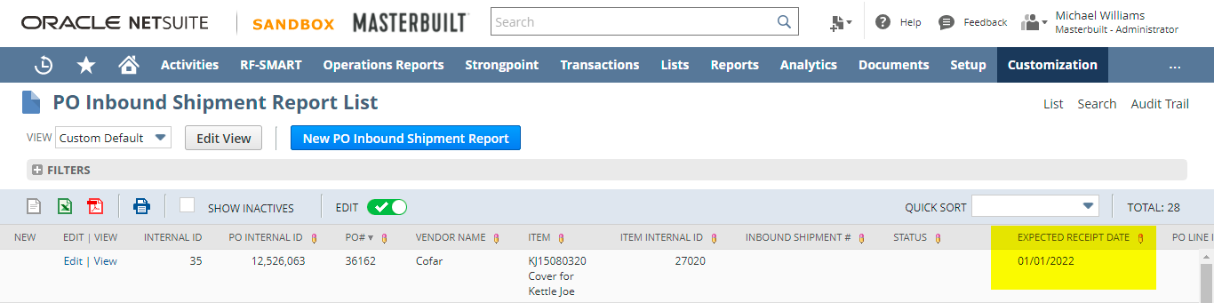

**Case 2:**

When inbound shipment is populated on the custom record, Expected Receipt Date is changed on the PO line. The new changed date should not populate on the custom record. Please see the below screenshots.

Open PO#36161

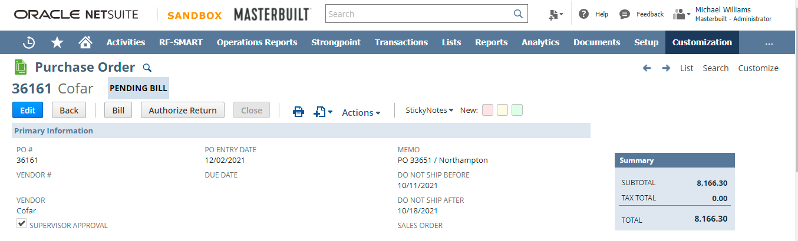

Click on the Edit button.

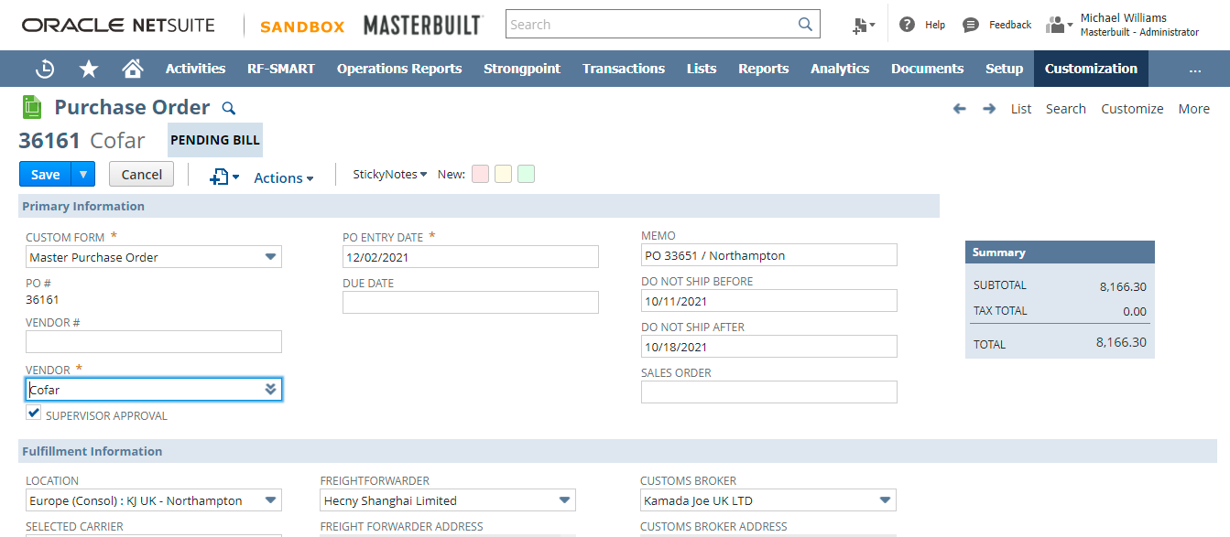

Go the Items sub tab and change the **expected receipt date** field.

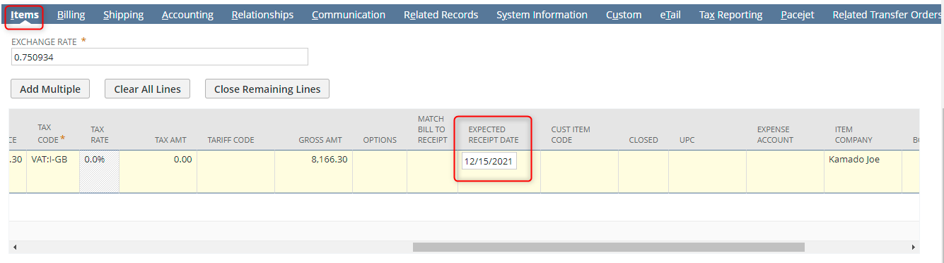

Change the expected receipt date from 12/15/2021 to 01/01/2022.

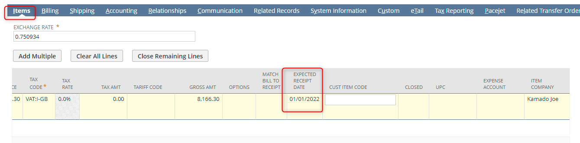

**PO Inbound Shipment Report Before Screen:**

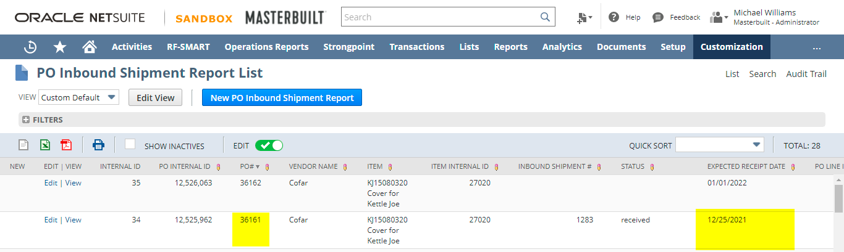

**PO Inbound Shipment Report After Screen:**

Refresh the page once.

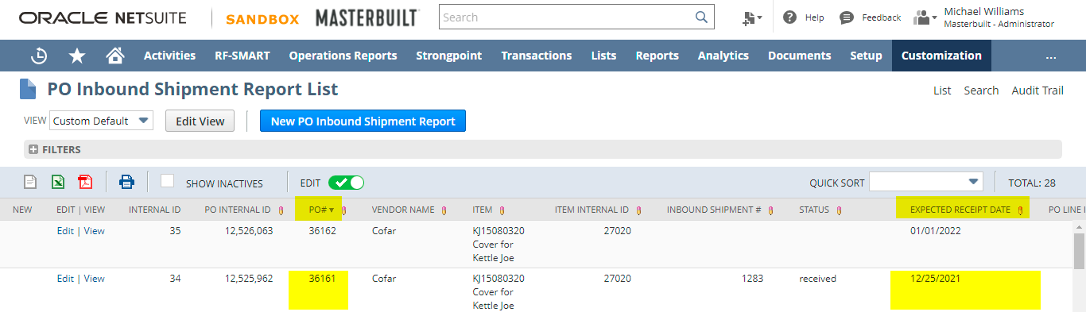

**Case 3:**

Create a purchase order without expected receipt date on the purchase order line. Custom record should be populate with the new purchase order.

Open PO#36161



Create a copy of it.

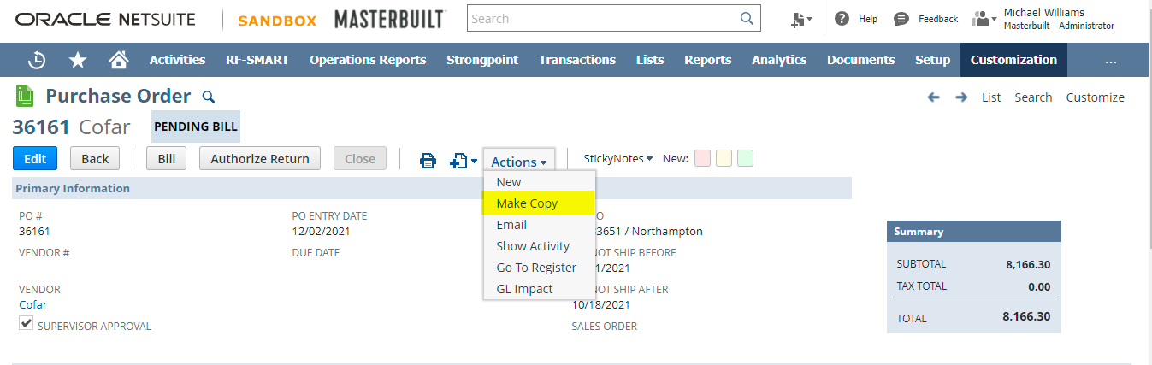

New purchase order screen will load.

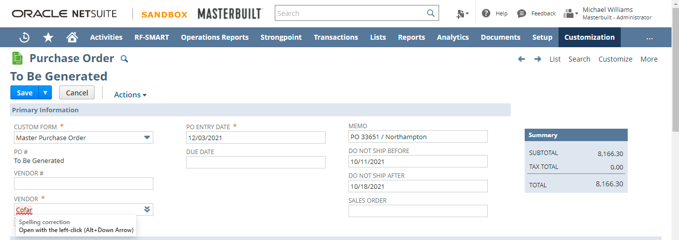

Remove the expect receipt date from Items subtab.

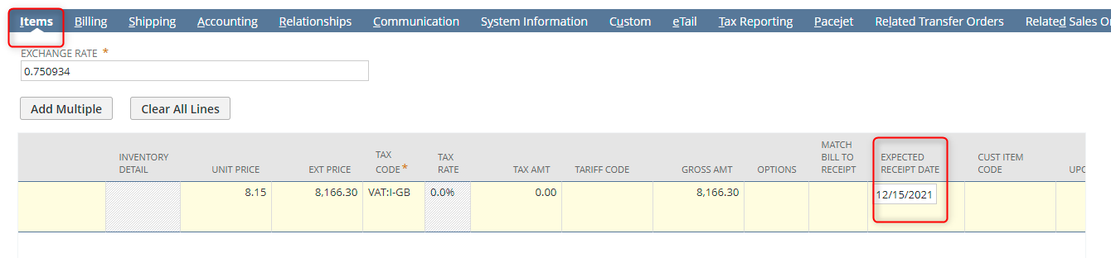

Removed.

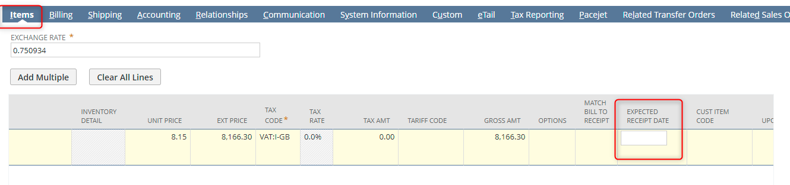

Click on the save button.

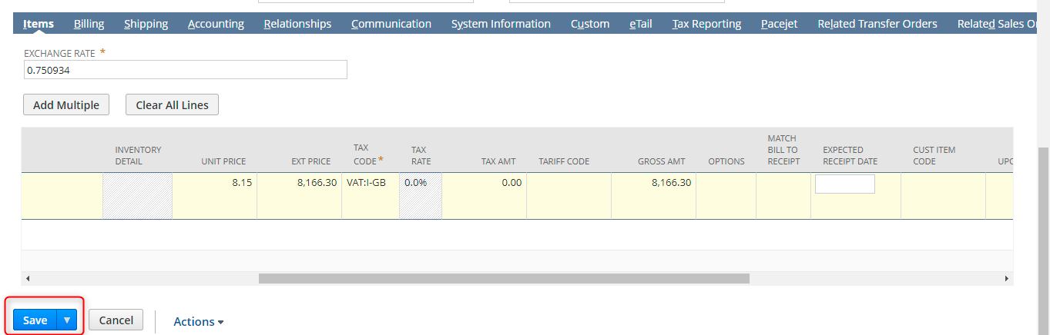

New purchase order created PO#36164.

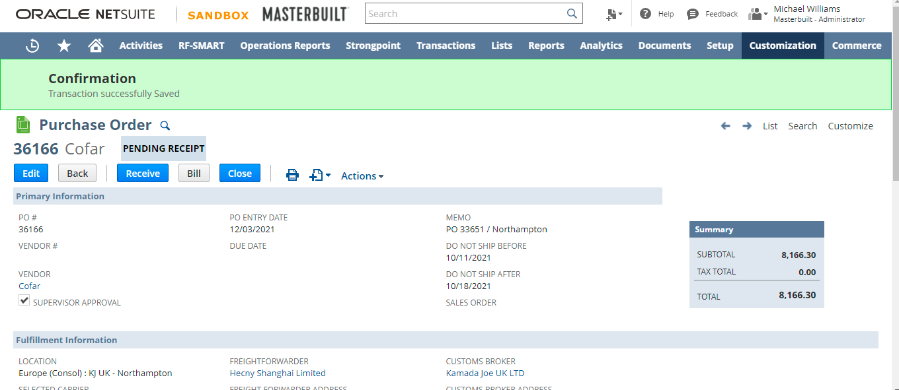

Check the PO Inbound Shipment Report. New purchase order should be populated.

